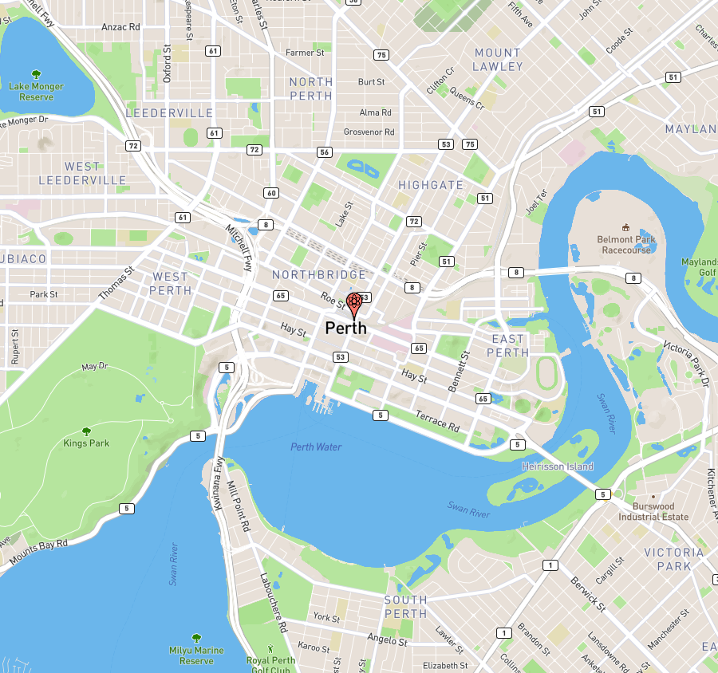**Impact of an Atomic Bomb Detonated in Perth**

|  |  |
| --- | --- |
| **Blast Effect** | **Impacts** |
|  |  |
|  |  |
|  |  |
|  |  |

Map Key:

|  |  |  |
| --- | --- | --- |
| Colour | Blast Zone | Size |
|  |  |  |
|  |  |  |
|  |  |  |
|  |  |  |
|  |  |  |
|  |  |  |

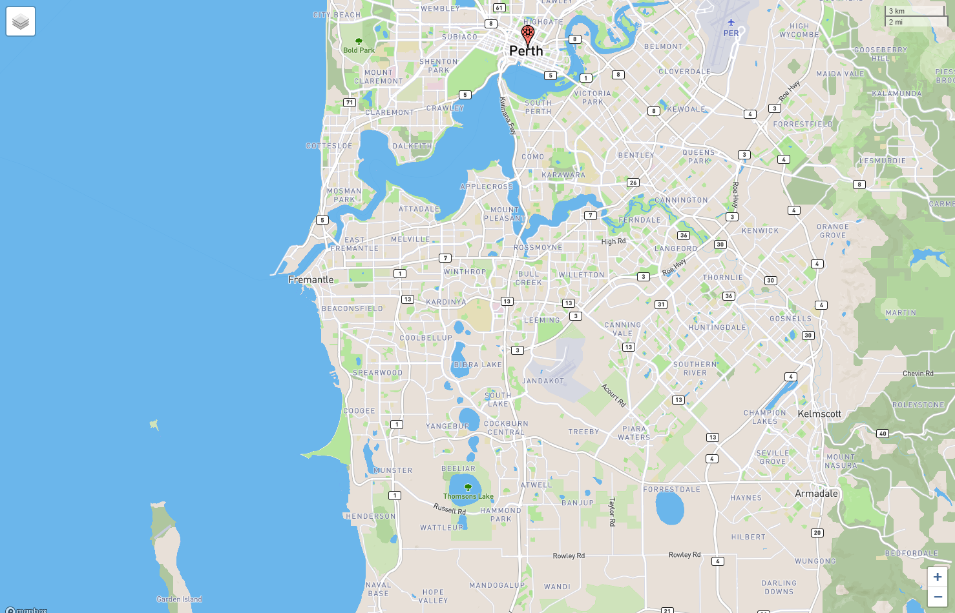

|  |  |  |
| --- | --- | --- |
| Colour | Fallout Zone | Length |
|  |  |  |
|  |  |  |
|  |  |  |
|  |  |  |

Nuclear Fallout